**State University of New York at New Paltz**

**John Berean**

**Project Type: Internship, Student’s “Class Key”: s19-03**

**“CSTEAM Q/A System”**

**FINAL PROJECT REPORT**

**Computer Science Projects**

**Spring 2019**

**(Prof. Hanh Pham)**

**TABLE OF CONTENTS**

**1. Problem Description**

**1.1 Business Context and Goals** ….……………………………………….…………….……. page 03

**1.2 General Information** ….……………………………………….…………….……. page 03

**1.3 Project Description** ….……………………………………….…………….……. page 03

**1.4 Technical Requirements** ….……………………………………………….……….………. page 03

**1.5 Your Responsibilities** ……...……………………………………………….……….………. page 04

**2. Technologies**

**2.1 Related Technologies** ….……………………………………….……………………..…….. page 05

**2.2 Newly Learned Skills/Technologies …**………………………………..………………. page 07

**3. Design**

**3.1 System Architecture** ………………….……………………………………….………………. page 09

**3.2 Components** ………………………….…………………………………………..………………. page 10

**4. Software/System Description** ………………………………………….……………..……..…………. page 12

**5. software 2.0 Updates / improvements to be made**

**6. Professional and Career Benefits** ……………………………….……..….…….……..……………. page 16

**7. Conclusions** ………………………….……………………………………………...…………..………………. page 17

# Problem description

## 1.1 Business context and goals

CSTEAM is a web-based question and answer site for students taking CS1 and CS2 at SUNY New Paltz. The goal is to create a functional website the will allow students to create an account and post questions they might have about problems, subjects or code. And in return user may also be able to respond to other questions posted by other students. The aim is to improve the learning process of students taking CS1 and CS2 similarly to Stack Overflow. But the website can eventually encompass more subjects such as CS3 or Discrete Math, based on the clients request and or student demand.

## 1.2 General Information

|  |  |
| --- | --- |
| **Date Requested** | *01/10/2019* |
| **Requested By** | *Chirakkal Easwaran, Hanh Pham* |
| **Email** | *jmberean@gmail.com* |
| **CO/CC** | *SUNY New Paltz Computer Science Department* |

## 1.5 Techinical requirements

Technical aspects that the system must fulfill.

* Register
* Login
* Uploading Questions
* Responding to Questions
* Searching for Questions
* Viewing All Questions
* Viewing a Single Question

**Register**

* Users may register with an account on our system. They do this by clicking the “Register” button on the top navbar, this will direct them to the “Register page”.
* Once there, potential account owners must provide their first name, last name, a unique username, email address and password.
* When submitted, the system will the use front end HTML code to verify valid entries have been entered in the first name, last name, email and password fields before passing the data to the back end. If the information is invalid, HTML code will display a relating error, keeping the user on the “Register Page”.
* Once valid data has been entered it will be passed to the register PHP code, which will attempt to insert the user’s information into the “User” table. Before doing so the function will hash the password using the MD5 message-digest algorithm producing a 128-bit hash value.
* If the username already exists in the “User” table PHP code will redirect the user back to the “Register Page” with a relating error.
* Otherwise, PHP code will insert the user’s information into the “User” table, create a login user session constructed from the username and redirect them to their “Profile Page”.
* Once a user has successfully registered they will be able to upload questions and respond to other uploaded questions. Along with all other functionalities listed above.

**Login**

* Successfully registered users may log in to their account from our website. They do this by clicking the “Login” button on the top navbar, this will direct them to the “Login page”.
* Once there, account owners must provide their username and password.
* When submitted, the system will the use front end HTML code to verify valid entries have been entered in the email and password fields before passing the data to the back end. If the information is invalid, HTML code will display a relating error, keeping the user on the “Login Page”.
* Once valid data has been entered it will be passed to the login PHP code, which will attempt to select the user’s information from the “User” table.
* To do that we must first hash the selected password using the MD5 hashing algorithm. If the username exists in the “User” table PHP code will create a login user session constructed from the username and redirect them to their “Profile Page”.
* Once a user has successfully logged in they will be able to upload questions and respond to other uploaded questions. Along with all other functionalities listed above.

**Uploading Questions**

* Successfully logged in users may upload questions from their account to the website. They do this by clicking the “Post” button located on the top navbar and bottom left of the “Profile Page”, this will direct them to the “Upload Page”.
* When directed there, users must provide valid information about a there question in the form of text.
* Once submitted, the system will the use front end HTML code to verify valid entries have been entered in the text fields before passing the data to the back end. If the information is invalid, HTML code will display a relating error, keeping the user on the “Upload Page”.
* Once valid data has been entered it will be passed to the upload PHP code, which will attempt to insert the questions information into the “Question” table.
* Once a user has successfully uploaded a question the will be redirected to their profile page.

**Searching for Questions**

* Users may search for Questions based on selected attributes. They do this by using the browse bar on the top of the list of questions.
* Once data has been selected it will be passed to the search java script code, which will attempt to filter from the question table according to the users input.

## 1.5 YOUR RESPONSIBILITIES

* Communicate with the client Chirakkal Easwaran to assure that the application meets the organizations objectives.
* Conduct multiple requirements analysis with the client Chirakkal Easwaran and acting manager Hanh Pham.
* Develop the reports and documentation for the system.
* Provide the manpower to design and develop the web-based application. Given other concurrent commitments, the development of this system took approximately 4 months.

## 2. technologies

## 2.1 related technologies

***HTML 5*** *– Markup language*

* HTML 5 is a software solution stack that defines the properties and behaviors of web page content by implementing a markup-based pattern to it.
* HTML 5 is the fifth and current major version of the HTML standard and subsumes XHTML.

***CSS*** *– Stylesheet language*

* Cascading Style Sheets is a style sheet language used for describing the presentation of a document written in a markup language like HTML.
* CSS is a cornerstone technology of the World Wide Web, alongside HTML and JavaScript.

***Bootstrap*** *- Front-end framework*

* Bootstrap is a free and open-source CSS framework directed at responsive, mobile-first front-end web development.
* It contains CSS and JavaScript-based design templates for typography, forms, buttons, navigation and other interface components.

***JavaScript*** *- High-level programming language*

* JavaScript, often abbreviated as JS, is a high-level, interpreted programming language that conforms to the ECMAScript specification. JavaScript has curly-bracket syntax, dynamic typing, prototype-based object-orientation, and first-class functions.

***PHP*** *– Programming language*

* PHP: Hypertext Preprocessor is a general-purpose programming language originally designed for web development.

***MySQL*** *– Database / System software*

* MySQL is an open-source relational database management system.

## 2.2 NEWLY LEARNED SKILLS/TECHONOLOGIES

Working on further developing my skills with PHP, MySQL and the intermingling of the two.

**Side Notes:**

- You have to include the "s" in "https" or the php sessions will not work.

- Setting admin level control i.e. the ability for one or a few users to moderate the website and

delete questions / responses that might be harmful or unwanted.

* This is simply done through the “vSingle.php” on line 62.
* Whatever user account you want to be in admin level control (This is something you only want the developers and possibly the client to have access to)
* Insert the username in the latter half of the or statement and this will allow them all the functions as for deleting questions / editing.

.

.

.

if ($result && mysqli_num_rows($result) > 0 || $_SESSION['userName'] == '**INSERT CHOSEN USERNAME HERE'**)

{

?>

<a class="btn btn-primary" href="editQuestionPage.php" role="button" style="font-size:15px">Edit</a>

.

.

.

## 3. design

## 3.1 System architecture

## https://documents.lucidchart.com/documents/711b3c8b-1673-4dfd-a89a-6bc39284deb4/pages/0_0?a=1678&x=2&y=128&w=1349&h=1632&store=1&accept=image%2F*&auth=LCA%2003ab530118438e9d520c90ac8c88eeff18fdfc2b-ts%3D1557003489

## 3.2 components

Register

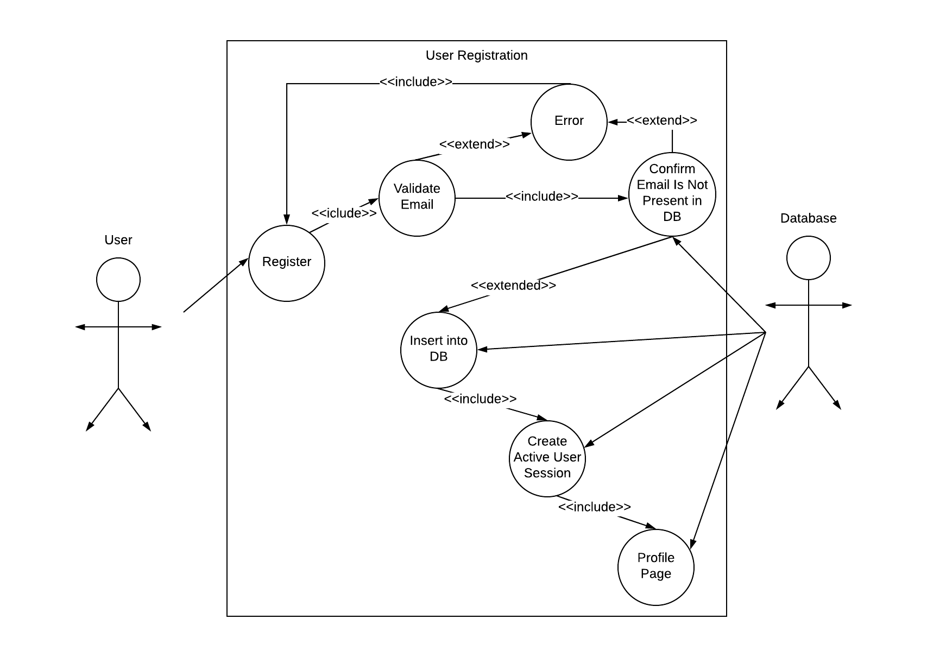

Login

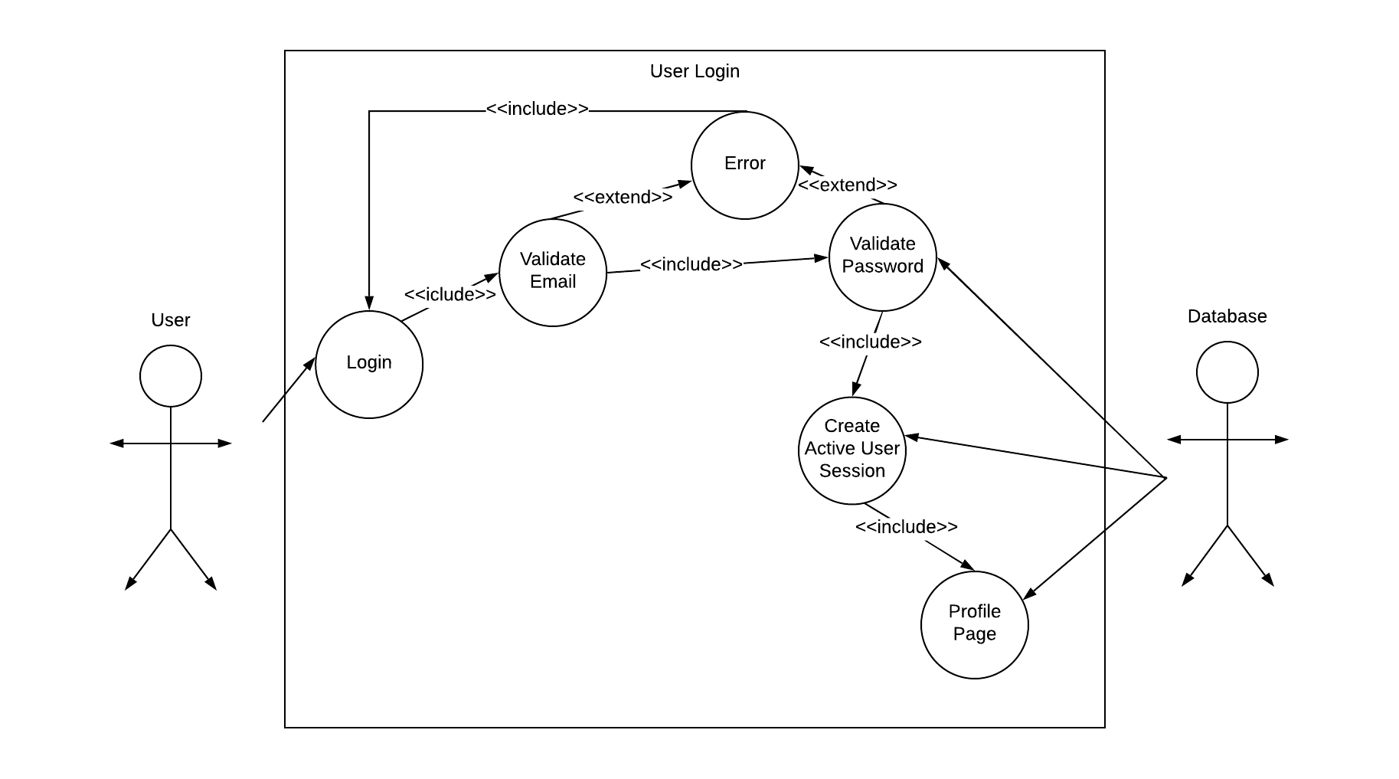

Uploading Questions

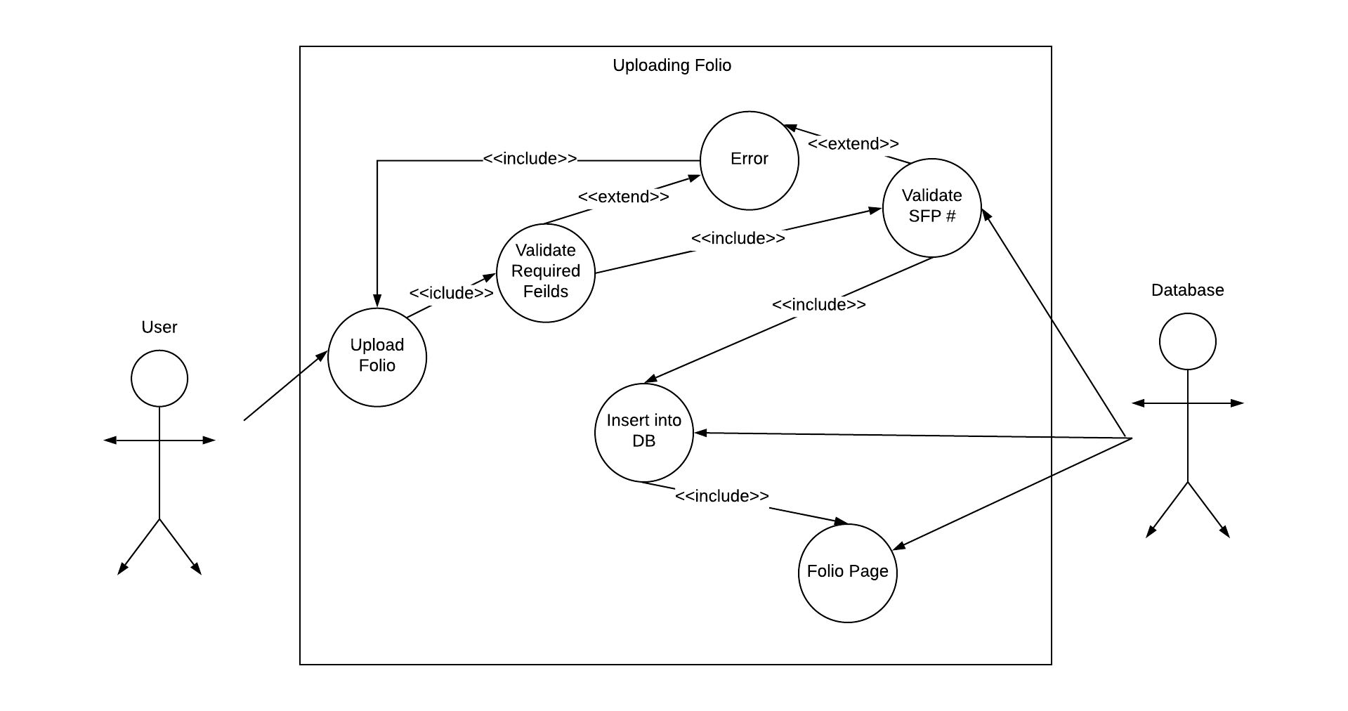

## 4. software/system description

The proposed CSTEAM web system will consist of a web-based, centralized database.

Generally, all users will provide direct input (Questions) into the system and outputs will also be generated directly from the system. However, to ensure growth ability, flexibility is also required for both input and output modes.

Participating administrators will have control over the system and database. The system is planned to be developed by myself.

|  |  |
| --- | --- |
| **Name** | *CSTEAM* |
| **Desired Start Date** | *1/20/2019* |

## 5. software 2.0 Updates / improvements to be made

* Uploaded questions should be ratable by other users. Meaning thumbs up and thumbs down (votes) so that you may sort questions further according to popularity/relativity.
* Reponses to questions should also be ratable. Meaning users can upvote or down vote responses. Furthermore, these responses to questions should be sorted underneath each question from highest upvote to lowest.
* Responses should be editable and depletable. They are not in the current 1.0 version of CSTEAM.
* Users profiles should have notifications. So, if other users respond to a question posted, the original user that posted the question will be altered.
* Questions should allow for files to be uploaded as well, including pictures and or text documents or code files.
* Depending upon client interest and or student demand other Classes may be implemented in the 2.0 version of CSTEAM. Such as CS3, Assembly Language, Discrete Math, etc. The sky is the limit on this one. If students are making responsible use of the website and there is an interest you may add any Class.
* There should be an advanced browse functionality that is more specific than the general browse bar. Student should be able to sort/filter our records by all attributes including users, questions, subjects, topics, etc.
* User should be able to visit other users’ profiles and view their questions.
* Users should be able to see the questions the have responded to in their profile page.
* Users can have a count of questions / answers they have posted as an extra attribute on their profile page.
* Questions should have a field that states whether the question has been successfully answered. This right will be allowed only by the original user that uploaded the question. This will help with efficiency so that users will easily be able to see which questions have been answered and which ones are awaiting successful answers.
* Users should be able to reset their passwords incase they forget them. This will involve adding an extra field for users emails, which is what you will use to send a password reset confirmation and process.

**6. Professional and Career Benefits**

* *Strengthened my web development skills.*
* *Improved on the programming languages (PHP, MySQL, HTML, CSS).*
* *Reinforced my presentation skills.*
* *Improved my ability to plan, design and implement a software system.*

**7. Conclusions**

***Great project and experience creating a system that will go to real world use. It was difficult at times and easy at others but all around improved my strengths with web development. I only wish I experienced this side of Computer Science much earlier in my time at SUNY New Paltz.***